Six Reliability Layers Around an LLM Sorted Its Answers and Fixed Almost None
Wejdan Bagais and Pushpdeep Mishra

Key takeaways
- Reliability layers do not make a model more accurate; they tell you which answers to trust, so judge them on correct answers over all inputs.
- Start with a check that costs nothing: matching answers' words to the vocabulary's own names sorted them by trustworthiness; three paid layers together changed one answer.
- Ask the model to read, never to remember: it picked well from a menu but invented 13 to 18 percent of codes asked of it.
- Make repeat runs a validation step: rerun the same inputs, measure how far answers move, set the difference you accept; ours agreed 70 percent at temperature 0.
- Study the data before adding layers: our biggest gains came from learning the corpus's annotation conventions, not medicine; no layer recovers what the model failed to read.

The promise, and the catch
Most of what an organisation knows about its own work is prose: clinical notes, incident reports, support tickets, forum posts. Language models can read it as nothing before them could.
A language model is not a dependable component, though. It can be 80 percent right and unable to say which 80 percent, and wherever a wrong answer costs something, that is unusable. The standard response is layers: check its output against something deterministic, send provable failures back [1], sample it and vote [2], have a second model judge it [3], withhold what cannot be corroborated, send the rest to a person. We wanted them priced against each other on the same records, with the zero-token check entered as a competitor.
That needs a task where "right" can be graded, so we chose CADEC, the CSIRO Adverse Drug Event Corpus [4]: 1,250 forum posts about two drugs, every adverse reaction marked as a span of the writer's own words and given a SNOMED CT code. It is the shape of much production work: records pulled from prose and normalised against a vocabulary.
Two caveats. A supervised system does this far better: CONORM [5], fine-tuned on 875 of CADEC's 1,250 files, reaches about 0.70 end to end against our 0.20. We did not use one: most teams have no 875 annotated files, and a fine-tuned model still cannot say which answers to trust. And we spent our held-out split once, 60 documents, one run; every other number is development-side and says so.
held-out split, 60 documents, run once | records | correct | accuracy
bare model, everything | 314 | 127 | 0.40
ACCEPT tier, shipped | 72 | 60 | 0.83
BAND and REJECT tiers, sent to a person | 242 | 67 | 0.28
End-to-end F1 of what ships is 0.204 span-exact. Errors per 100 records: 59.6 bare, 3.8 shipped.
As a product this is not shippable: three quarters of the batch went to a person, and that tier holds more correct answers than the shipped one. As a signal it is the result: a zero-token check split two-in-five odds into five in six and two in seven. It improved nothing; it sorted.

The pipeline: the model reads, the vocabulary knows
The model is never asked for a code, and everything above it depends on that choice.
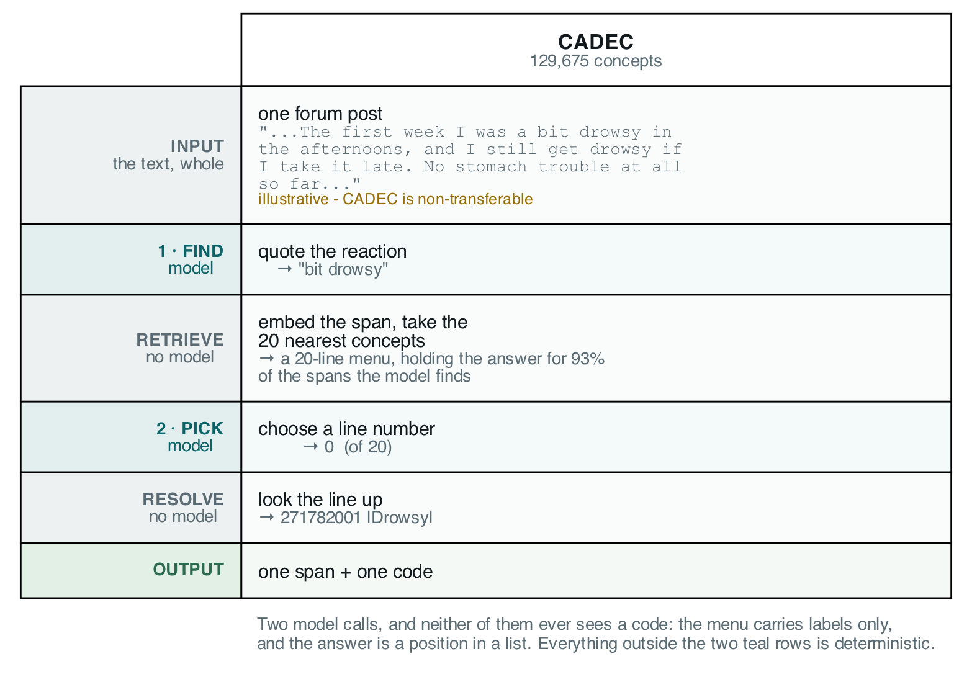
Figure 1: The pipeline. Two model calls, and neither ever sees a SNOMED code. Everything between and after them is deterministic. Image: the authors.
The first call is given the whole post and asked to quote every reaction in the writer's exact words, including denied ones, and twice if described twice. CADEC is non-transferable, so this post is ours:
Been on this for arthritis pain for about three months now. The first
week I was a bit drowsy in the afternoons, and I still get drowsy if I
take it late. No stomach trouble at all so far, which is more than I
can say for the last one. Some days I just feel awful and have no stamina.
The model returns six spans, including the condition the drug treats, the drowsiness twice and the denied stomach trouble. A retriever with no model in it then embeds each span against 227,554 keyword-to-code rows and lists the twenty best-scoring concepts as a numbered menu. The real menu for "bit drowsy":
[0] drowsy
[1] dizziness - giddy
[2] dizziness
[3] gets drowsiness
[4] bites self
...
[19] epidemic dropsy
Line 0 is right; several below it match the letters b-i-t. The second call is given the menu and asked for a line number, or null. It answers 0, and a lookup table turns line 0 into code 271782001, named |Drowsy| in SNOMED's bar notation, used throughout. The code was looked up, never generated.
We arrived at this shape by measuring the alternatives, 40 development documents, three cold runs each:
 | recall the code | name the concept | pick from a menu (shipped)
the model returns | span, concept name and code | span and concept name | span, then a line number
where the code comes from | the model's memory | a lookup on the name | a lookup on the line
F1 span-exact, three runs | 0.030 · 0.030 · 0.024 | 0.252 · 0.253 · 0.276 | 0.393 · 0.393 · 0.434
tokens per run | 141,000–147,000 | 82,000 | 155,000–162,000
replies that would not parse | 3 of 40, every run | 1 · 0 · 0 | 0
The first column is not weak but broken: eight to twelve times worse than the second. It answered null on up to 38 percent of records, and of the codes it committed to, 13 to 18 percent exist in no SNOMED release. An abstention hatch reduces fabrication; it does not remove it.
One convention holds throughout: F1 is span-exact, so quoting "extreme rectal bleed" where the annotators wrote "rectal bleed" counts as a false positive and a false negative.
Above this sit the six layers; the judge is a different model family from the extractor, or it would measure self-consistency. Testing whether they stack meant first knowing what noise looked like, and we got that wrong.

We nearly published a result that was not there
Three identical runs of the unchanged system differed by four points of F1, at temperature zero.
We ran the extraction step three times, cold, on the same 40 documents, at temperature 0. Two were byte-identical; the third diverged from its fifth request on: 87, 87 and 98 correct of 226, four points of F1. It still agreed with the pair on 70 percent of mentions outright, and on 84 percent of codes where all three found the same span; the remainder was worth those four points.
The case that taught us was a menu reranker. A paired bootstrap over documents excluded zero; on the second run the gain was smaller, and on the third the sign reversed. The test answers would this hold on different documents?, never on a different run?, and here the run-to-run term is the larger one.
Worse: the helper computing those intervals wrapped random.choices in set(), deleting the duplicates a bootstrap depends on, and ran that way for a month because the intervals looked fine. Re-tested at three runs, one headline claim did not survive.
A wrong number that looks wrong gets found. A wrong number that looks right becomes evidence. From here on, every change was measured on three runs, all reported.

What each layer bought, and what it charged
The check sorted and refusal withheld; neither corrected anything. The three paid layers could not be tested, could not be shown to help, or were not read.
layer | what it is for | did it do that? | cost per run
vocabulary check | sort into lanes, not raise accuracy | yes: the lanes separate 2.7–2.8× | 0 tokens
self-correction | restate a provable failure as a fact | barely exercised: fired 2, 2 and 3 times, corrected none | ~1,500 tokens
voting | catch answers the model cannot reproduce | no: net +1, −1, −1; destroyed 2, 3 and 5 right answers | 411,000–432,000 tokens
second-model judge | rule on whether an answer is right | yes, once shown the menu: 3.4–4.2× separation; read by nothing | 84,000–88,000 tokens
refusal | guard in front of a person | yes: ships at 0.74–0.82 accuracy on 21–23% of records | 0 tokens
person | resolve what the machine cannot | not measured | 177, 177 and 187 records
Development split, three runs, 230, 230 and 238 records over 40 documents.
The vocabulary check sorts every record into three lanes: REJECT, the code does not exist or the quote is not in the post; ACCEPT, the span's text matches one of the concept's own names, "chronic pain" against |Chronic pain|; BAND, neither.
Scored afterwards, ACCEPT is 75.5, 75.5 and 82.4 percent correct and BAND is 26.9, 26.9 and 30.4 percent: a 2.7 to 2.8× separation for zero tokens. The check can prove an answer cannot be right. It can never show that it is.
Its precondition, tested by one query over the answer key: only 73 of the 226 development mentions can land in ACCEPT, 32 percent of a perfect answer set, because the writer's words and the vocabulary's names coincide only that often. The other 68 percent is the paid layers' bill.
Self-correction fires only on REJECT, so it fired 2, 2 and 3 times per run and corrected nothing: unmeasured, not refuted.
Voting costs 2.5 to 2.8 times the extraction step and changed about 27 codes a run, as many right to wrong as wrong to right, mostly on spans that sit on no annotated mention. The voter is the answerer, so a vote carries no information the answer lacked.
The judge is a 3.2B-parameter model grading a 20B one, and as first built it barely separated right from wrong: we had shown it a nine-digit code and neither the concept's name nor the menu. Shown what the extractor was shown, it separates twice as well and gains a verdict it could not express blind, the right answer is not on this list. And then: nothing reads its verdict.
Refusal ships ACCEPT and withholds everything else. That is the setting we measured, not a recommendation. A confidence threshold was retired: the extractor reports 1.0 on 66 percent of answers and never below 0.9, while right 39 percent of the time.
Then we deleted the three paid layers, replayed refusal and counted the change. One shipped answer of 53 on the first run, none on the other two: voting overwriting a correct |Pain| with |Increased pain|.

It is a dial, not a staircase
Every verdict carries information. None makes the system produce more right answers, and they do not stack.
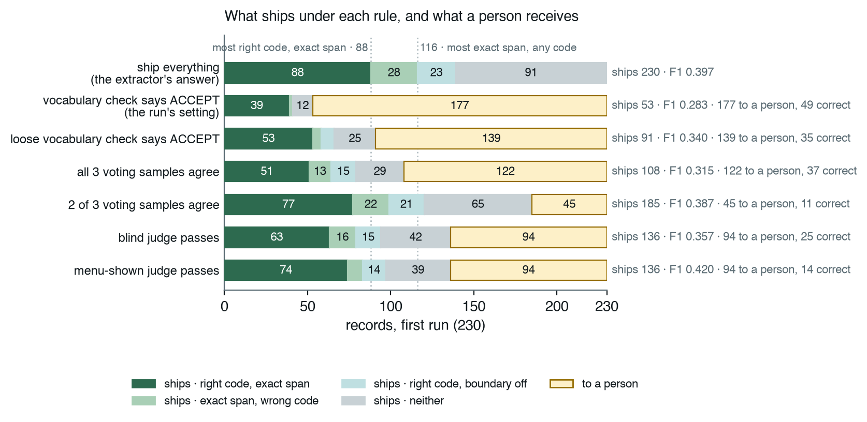
Figure 2: The first run's 230 records under each shipping rule. Dark green: right code on the exact span; light green: exact span, wrong code; light teal: right code, boundary off; grey: neither; amber: to a person. Image: the authors.
Read each verdict as a shipping rule over the same records, and the layers become settings of one dial:
ship only when… | ships | to a person | correct | accuracy | yield | F1 | tokens per run
the extractor says so: everything, after voting | 233 | 0 | 90 | 0.39 | 0.388 | 0.405 | 0 extra
the vocabulary check says ACCEPT (the run's setting) | 52 | 180 | 40 | 0.77 | 0.173 | 0.292 | 0
the loose vocabulary check says ACCEPT | 91 | 142 | 55 | 0.61 | 0.236 | 0.353 | 0
all three voting samples agree | 116 | 117 | 57 | 0.50 | 0.246 | 0.345 | ~420,000
at least two of three samples agree | 186 | 46 | 79 | 0.43 | 0.341 | 0.396 | ~420,000
the blind judge passes | 138 | 94 | 65 | 0.47 | 0.278 | 0.363 | ~84,000
the menu-shown judge passes | 141 | 91 | 77 | 0.54 | 0.331 | 0.430 | ~84,000
Means over three development runs of 230, 230 and 238 records against 226 annotated mentions. Accuracy is correct over shipped; yield is correct over all records; F1 is span-exact on what ships, so a withheld answer is a miss. Voting rows send a split or a missing sample to a person; the loose check accepts a span contained in a concept name.
Filter on any verdict and accuracy rises above the 0.39 of shipping everything, so the paid verdicts were not noise, and every row ships fewer correct answers because every one withholds. F1 sees both sides. ACCEPT and strict voting give up eleven and six points of it to send half or more of the batch to a person; the loose check, loose voting and the blind judge land within about five points of shipping everything; only the menu-shown judge clears it, by two to three points on every run, for 84,000 tokens.
The dotted lines in Figure 2 are the ceiling: no rule ships more than 88 right codes or 116 exact spans, because that is all the extractor found. Everything right of that line is the next section's loss.
Abstaining always raises precision, whatever you abstain on and however badly. Yield cannot be fooled that way, so we print it beside accuracy. Moving from the top row to the run's setting means 128 fewer errors, 49 fewer correct answers and 177 more records for a person; the correct answers given up outnumber those kept. Each row is what you get by shipping on that verdict; we choose none.

Where the system actually loses
The domain knowledge was never missing. The model loses at reading, and nothing above it can see what it did not read.
We tried two specialist models and rejected both: a domain-adapted encoder put more right concepts on the menu and the picks got worse; a domain-adapted generator would not answer.
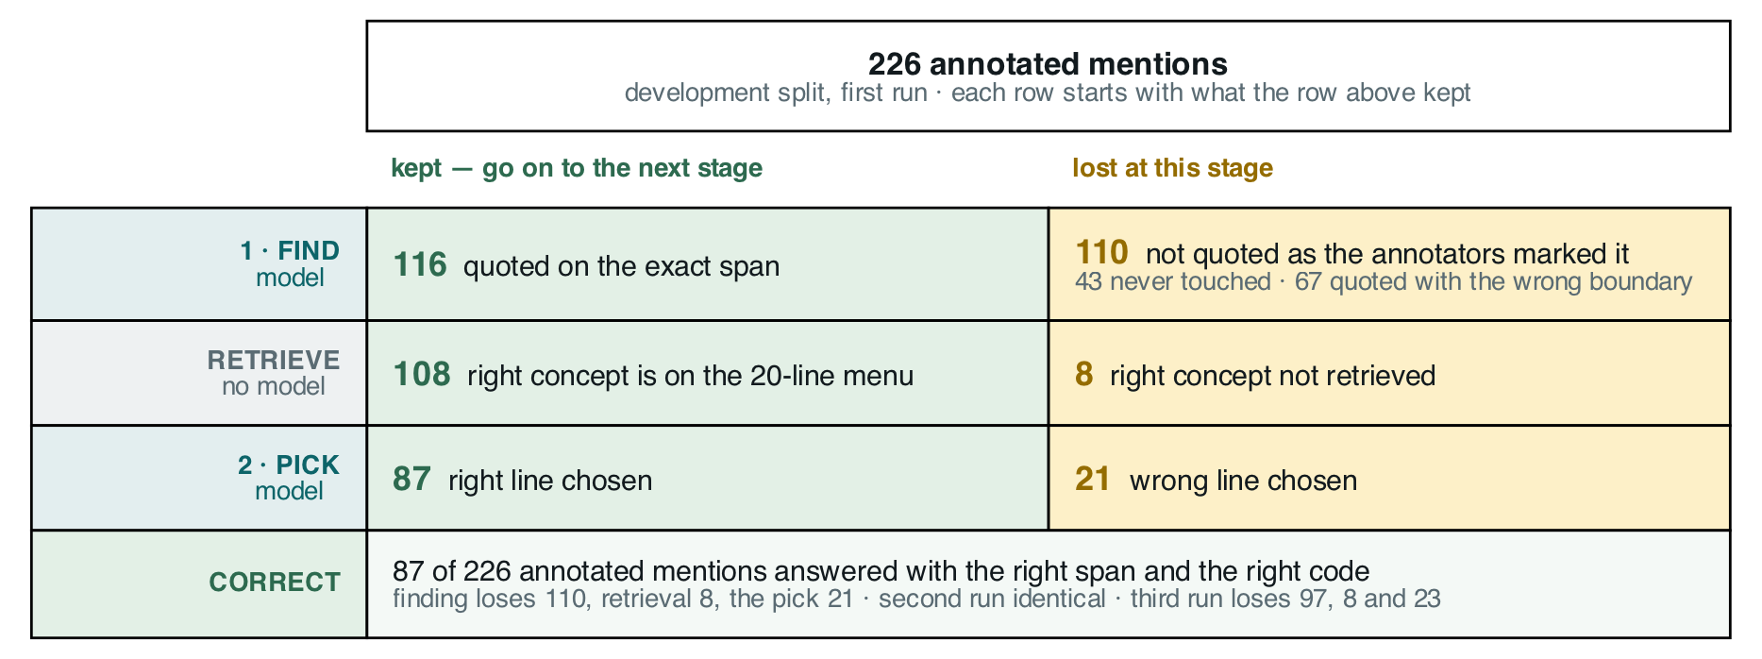
Figure 3: Where the 226 development-split annotated mentions go, first run. Green is what survives to the next stage, amber is what that stage loses: 226 → 116 → 108 → 87. Image: the authors.
Once the right concept is on the menu, the model picks it 81 percent of the time, and the retriever puts it there for 93 percent of the spans the model finds: the specialist half is fine. It loses at finding: 110 of 226 mentions are not proposed as the annotators marked them, and 31 proposed spans sit on nothing.
Neither failure is medical. The 43 mentions the model never touched are single words like "sore"; the 67 with the wrong boundary are "extreme rectal bleed" for "rectal bleed"; the 31 inventions are figures of speech read literally, "at my wits end" coded as |Wanders at night|. Our two largest gains were a worked example in the corpus's conventions and a rule to extract denied reactions; no domain model supplied either.
One limit is structural. Every layer operates on records the extractor already proposed. The ladder's ceiling is the extractor's detection, 0.521 exact on the held-out split.

Why none of it showed up in a test
Every layer passed its own tests. The failures were between them, and in a metric that could not see them.
Only one verdict travels through the ladder, the vocabulary check's; self-correction, voting and the judge each write a field that nothing reads.
Then the metric. Voting overwrote codes without re-validating, so records shipped marked verified for a code they no longer held. Fixing that moved exact F1 from 0.204 to 0.204: precision and recall cannot tell an unwarranted answer from a wrong one. We built six layers to decide which answers to trust, then scored them with a metric that cannot see the difference.

What to do on Monday
What transfers is not the ladder but five practices and a division of labour.
- Understand the data before you add a layer. Our two largest gains came from studying the corpus.
- Condition your confidence on something that does not resample: a vocabulary, a schema, a compiler. Then test it against the answer key, where every rejection is false by construction.
- Measure your floor before you measure an improvement. Three runs minimum, all reported, and decide what difference you will accept; run any go/no-go probe on the denominator the change will be scored on.
- Grep for the readers of every field you write. Forty lines of regex found three unread verdicts; months of green tests had not.
- Check that your metric can see the defect you are preventing. Print yield beside accuracy; a layer that withdraws answers looks good on the wrong column.
The division of labour follows. The model reads and proposes candidates, the one thing nothing else can do. Code holds the knowledge: a lookup recalls identifiers, an index narrows the candidates, deterministic checks verify existence, format, grounding and type. A second model, shown the evidence, may judge; the model should not grade itself. Which verdict to ship on is yours: three currencies moving in three directions, and a break-even only the deployer has.

What we could not settle
- Why a model at temperature 0 repeats itself on two runs and not the third. Sent alone eight times, the diverging prompt returns one reply; it moves only inside a full run.
- The looser vocabulary match. It wins on yield in all three runs and roughly triples errors per hundred records; we show both and pick neither.
- We assume exactly one code is right. Where two concepts share a name, a defensible synonym scores wrong; how much miscoding is of that kind is unmeasured.
- The judge is a 3.2B model grading a 20B one, and CADEC is from 2015 and almost certainly in pretraining data. Absolute numbers would move with those; the comparisons would not.
We set out believing that stacking reliability layers buys reliability. Measured end to end, they sorted the answers by how far to trust them and fixed almost none: worth a great deal, and not what we bought them for. The model reads. Almost everything else belongs to code, and one choice to you.

Code, ledger, decision records and every figure's source: github.com/wbagais/reliability-ladder. CADEC is non-transferable; we ship document IDs, never text.

References
- Madaan et al., Self-Refine: Iterative Refinement with Self-Feedback, 2023. arxiv.org/abs/2303.17651
- Wang et al., Self-Consistency Improves Chain of Thought Reasoning in Language Models, 2022. arxiv.org/abs/2203.11171
- Zheng et al., Judging LLM-as-a-Judge with MT-Bench and Chatbot Arena, 2023. arxiv.org/abs/2306.05685
- Karimi, Metke-Jimenez, Kemp and Wang, Cadec: A corpus of adverse drug event annotations, Journal of Biomedical Informatics 55, 2015. doi.org/10.1016/j.jbi.2015.03.010
- Yazdani, Rouhizadeh, Bornet and Teodoro, Context-Aware Entity Normalization for Adverse Drug Event Detection (CONORM), medRxiv 2023. doi.org/10.1101/2023.09.26.23296150

About the authors
Wejdan Bagais and Pushpdeep Mishra.

